Look at the pictures and describe the people
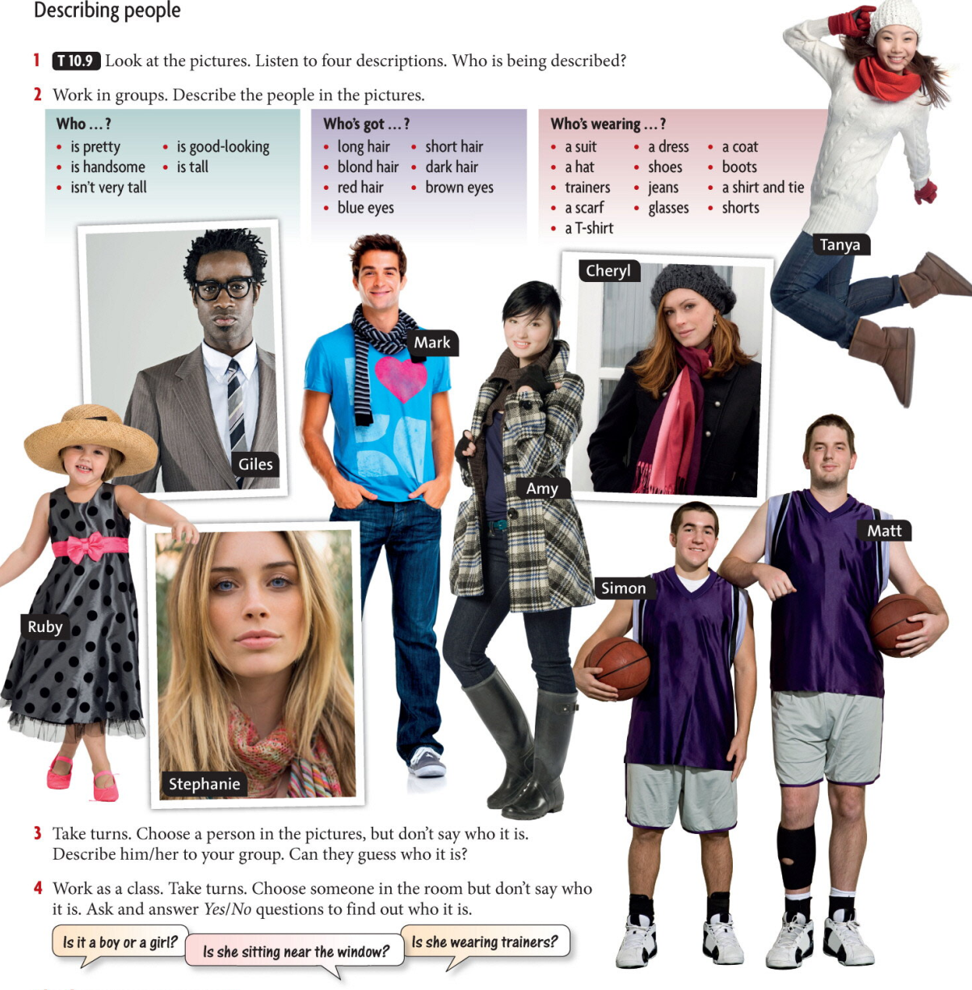

Home Task
Compare two people in your family.
Include:
What they look like
Their personalities
What they like doing

